**UNHLS-CPHL**

**REPORT ON HLIMS TRAINING ON ESSENTIALS TO INFORMATION MANAGEMENT IN THE LABORATORY.**

**Funder: ASLM-CDC**

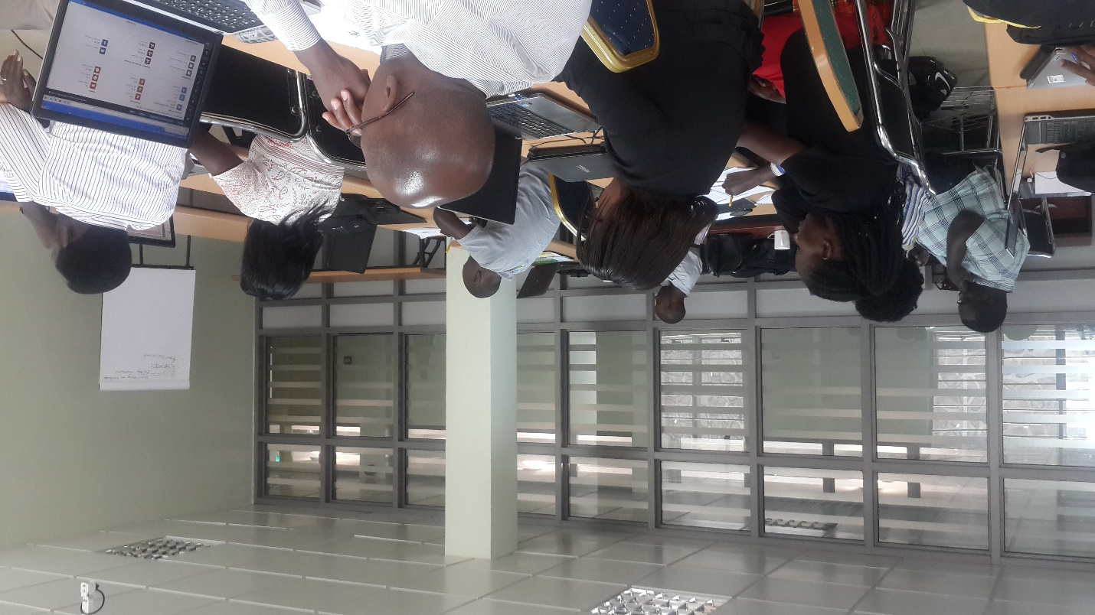

**Findings and Recommendations (19-23th June 2017)**

1. **Introduction**

Data collection and information remains a major driving force in the health sector today. Its major function is to inform decision makers in time to ensure fast and correct treatment to patients and strategic decision making. An electronic information management system is usually adopted to ensure information reliability and timeliness.

The UNHLS-HLIMS TWG developed an electronic Laboratory Information System for this function. This e-LIS has been tested and validated by a wide range of people in different disciplines. We now have got to that critical phase of piloting it in 12 identified sites. Prior to the pilot the HLIMS-TWG conducted a TOT to equip the assigned HLIMS focal persons and mentors with skills in maintaining the HLIMS equipment on site and ASLM-LIS utilization.

The participants targeted for this training were majorly the data focal persons within the laboratory or a QA officer from the 12 identified pilot sites. The first day of the training was dedicated mainly to HLIMS advocacy with the top facility and district management. This included the DHOs, Regional Referral Hospital Directors, Medical Superintendents and Health Centre Incharges of the 12 pilot sites.

1. **TRAINING OBJECTIVES**

The purpose of the course was to improve the ability of laboratory personnel in understanding the importance of Laboratory Information Systems and the newly data collection tools developed in ensuring product availability and other aspects involved in the logistics management system and also the linkage between logistics and SLMTA in improving laboratory systems.

This course report provides the summary of how the course was conducted including: course objectives and content, trainees’ composition, facilitation, course assessments and recommendations.

* 1. **Major Training Objectives**

1. To Advocate for the HLIMS Master plan and electronic (BLIS) buy in by the stakeholders
2. To describe the importance of a Laboratory Information System in any facility.
3. To describe the reporting structure of the Ministry of Health.
4. To describe the pros and cons of using a manual paper based LIS.
5. To Describe the HLIMS Master plan 2016.
6. To illustrate the business process for the first set of data tools developed.
7. To have a walk through the existing HMIS tools in the laboratory and suggest other tools that could be used.
8. To present the newly developed first set of Laboratory data capture and reporting tools to the 12 pilot sites.
9. To introduce the HUB module for downloading and printing of individual VL and EID results at the HUB.
   1. **Course Content**

The Course covered the following sessions:

* Introduction to the course.
* Roadmap of UBLIS implementation.
* Describing UNHLS HLIS & Its Importance
* Reporting structures of MoH.
* Quality lab practice background (ISO 15189 / SLMTA) with emphasis on information management in labs.
* Laboratory business Processes flow.
* HMIS tools in Lab Processes flow.
* Data Demands & Information use.
* Describing a Manual/Paper Based system.
* Walkthrough the tools portfolio that will be introduced to the 12 pilot sites.
* Introducing a Facility Laboratory Test Request & Report Form.
* Introducing a Facility Laboratory Reception and Rejection Register.
* Introducing a Facility Laboratory Referral Form.
* Introducing a Facility Laboratory Referral Register.
* Introducing a Facility Sample Storage & Aliquot Register.
* Introducing a Facility Microbiology test request & Report Form.
* Introducing a Facility Microbiology Daily activity Register.
* Introducing a Facility Bio-safety & Bio-Security report form.
* Introducing a Facility Bio-Safety & Bio-Security Register.
* Introducing a Facility Laboratory Equipment Break down report form.
* Introducing a Facility Laboratory Equipment Break down Register
  1. **Training Facilitation**

This course was coordinated by Kasule Daniel, the HLIMS Coordinator at UNHLS-CPHL.

Facilitation for the course was conducted by trainers from CPHL with Dr. Agnes Nakakawa taking lead. Facilitator details are described in the table below.

**Table 1: Facilitator details**

|  |  |  |
| --- | --- | --- |
| **Name** | **Position** | **Organisation** |
| Dr. Agnes Nakakawa | HLIMS Consultant | CPHL |
| Mrs. Mbabazi Prossy | e-Services Manager | CPHL |
| Dr. Kalyesubula Simon | Lab M&E Advisor | EAPHL-CPHL |
| Mr. Kasule Daniel | HLIMS Coordinator | CPHL |
| Mrs. Kyozira Carol | Senior Bio-statisti | DHI-MoH |
| Mr. Ntale Johnathan | Lab. ICT Advisor | CDC |
| Mr. Kasule Daniel | HLIMS Coordinator | CPHL |

The sessions were comprised of teach back sessions, to allow presentation of the modules according to the design packages. This was done through power point presentations, flipchart illustrations, handouts and discussions as per the training schedule.

Tests were administered to participants in 2 sets; a pre test to assess the knowledge participants had before the training and post test to assess the knowledge gained after the whole training.

* 1. **Course Assessment**

|  |  |  |  |  |  |
| --- | --- | --- | --- | --- | --- |
| **Unique ID** | **Name** | **Facility** | **Pre-test%** | **Post-Test%** | **Improvement %** |
| 1 | Namusoosa Ritah | CPHL | 31 | 66 | 35 |
| 2 | Osiika Francis | Mityana Hosp | 21 | 61 | 40 |
| 3 | Nabawanga Harriet | Mukono HC IV | 46 | 66 | 20 |
| 4 | Mukasa Aiysu | Jinja RRH | 36 | 58 | 22 |
| 5 | Mbabazi Rachael | Masaka RRH | 21 | 51 | 30 |
| 6 | Kiruuta Abdul | Gombe Hosp | 48 | 66 | 18 |
| 7 | Katende Misusera | Butabika NRH | 36 | 52 | 16 |
| 8 | Nambozo Harriet | Masaka RRH | 28 | 58 | 30 |
| 9 | Pimundu Godfrey | CPHL | 48 | 66 | 18 |
| 10 | Lyake Getrude | Kawolo Hosp | 26 | 61 | 35 |
| 11 | Kasumba Moses | Gombe Hosp | 36 | 72 | 36 |
| 12 | Bazimenyera John | Butabika Hosp | 41 | 86 | 45 |
| 13 | Bikumbi Patrick | Jinja RRH | 51 | 81 | 30 |
| 14 | Kasozi Corlder | DHO Gomba | 31 | 71 | 40 |
| 15 | Muwanga Enosh | Luwero HC IV | 32 | 68 | 36 |
| 16 | Kata KAsim | Kawolo Hosp | 36 | 78 | 42 |
| 17 | Kasibante Samuel | Jinja RRH | 45 | 88 | 43 |
| 18 | Miiro Shafik | Maddu HC IV | 41 | 81 | 40 |
| 19 | Ovuga Jino | Mukono HC IV | 41 | 78 | 37 |
| 20 | Nsibuka Edward Jonah | Mubende RRH | 22 | 81 | 59 |
| 21 | Musisi Fred | Luwero HC IV | 32 | 68 | 36 |
| 22 | Bwonyo Patrick | Mbale RRH | 42 | 66 | 24 |
| 23 | Sisye David | Mbale RRH | 27 | 51 | 24 |
| 24 | Mugabi Alex | HC IV | 41 | 62 | 21 |

1. **Recommendations**

**Table 2: comments on specific tools in set 1**

|  |  |  |  |
| --- | --- | --- | --- |
| **#** | | **Name of tool** | **Comment** |
| RRT | 1 | Facility Laboratory Test Request & Report Form | * Clearing of the entire entry for a deleted test in the list of tests added. * Results for test type “culture and sensitivity” need change in case of ‘no bacteria’, the organism should be ‘non’ * Changes to be done on the measures of urinalysis * Additional drop down list for reasons of rejection. * Rejecting officer’s details to be automatically captured * On list of completed tests, changes need to be done after a search for particular patient and unanalysed tests also displayed * Numbering of report pages * The first section of the report should include “Requesting clinician” and “Lab section” * The last section of report should have “Tested by” and “Reviewed by” * Units for turn-around time needs to be specified * Age ranges for infection report need change |
| LDSR | 2 | Microbiology test request & Report Form | * Numerous edits recommended |
| BB | 3 | Facility Bio-safety & Bio-security incident form | * “Cause of incident” needs a field for typing. * Notification when a response is back from the district, to be added * Field for “Root cause analysis” needs to be added * “list of persons involved” field for root cause analysis to be added |
| ELS | 4 | Equipment inventory register | * The word “Stockout” needs to be changed. * Stock book shouldn’t have negative balance * “Check balance” is to be added |
| 5 | Facility Laboratory Equipment supplier | * Field for a contact person needs to be added when adding a “Supplier” * Edit for equipment need to be added. * Equipment status(new/old/reconditioned) need to be changed. * Equipment might either be functional or non-functional. |
| 6 | Facility Laboratory Equipment Break down Register | * ‘Request of HSD’ should be removed. * Field for ‘Actions taken’ should be made two. One for actions taken from the facility and the other action taken from out. * The dates need to be standardized. * Occurrence is either major or minor * Restoration icon needs to be labelled. |
|  | 7 | Laboratory Equipment maintenance log | * Date of ‘next service’ need to be auto generated. * ‘Supplier’ should be auto generated from the earlier on captured data. * Page freezing |

1. **Methodology**

There were a number of methods/techniques used when training

* Lectures

The historical background of ALIS was narrated with HLIMS master plan explained and the relevance of the system to the facilities.

* Mentoring

With the different categories of people i.e trainers, mentors and focal persons, the experienced trainers and mentors were guiding the focal persons on the use of the system.

* Group discussions

As an unfamiliar program that is to be implemented, a group discussion on the new program allowed the focal persons to ask questions and provide ideas on how the program would work best.

* On the job training

As it is known that the system is to be used in the facilities, with the help of the trainer and the reading material(ALIS Guide), the participants had to test out the system by practicing using their laptops.

* Film/video

As a way of recap, a video was played that explained the basics of how to use a desktop.

* Planned reading

Reading materials were provided so as to guide in the training and explain what the training was all about. The materials enabled them read ahead and think of questions.

1. **Closing Remarks**

Closing remarks were made by the UNHLS-CPHL eService Manager, CDC representative and the Division of Health Information senior biostatistician. They appreciated members for the participation and called upon all participants to implement the changes and knowledge gained from the workshop. They emphasized the need for a good Laboratory Information system and requested CPHL to organize supervision and mentorship programmes for these sites to ensure the tools introduced during this training are utilized. They Thanked participants for attending and showing interested in the training and up hailed The HLIMS TWG for their continued effort to improving Laboratory Information systems in the health facilities and hospitals.

1. **Follow up**

The UNHLS-CPHL HLIMS-TWG will have a chance to revise the changes suggested during the week’s training. This will give them time to have the tools printed as well. There after a team will distribute the tools to each individual site for piloting. In January the team will revisit the sites and spend 2 days supervising and mentoring in the utilization of the data capture and reporting tools.

1. **Conclusion**

The workshop objectives were achieved to a very large extent, especially as all module units were thoroughly presented. All participants were exposed to all modules and anticipated queries were all answered. This is the first training of many and it has given the HLIMS TWG a sneak pick into the scale up training sessions and how better to conduct the training.

**7.** **Appendix**

* 1. **SCHEDULE FOR THE 5 DAY HLIMS TRAINING WORKSHOP 19th– 23rd June 2017**

|  |  |  |
| --- | --- | --- |
| **Time** | **Activity** | **Presenter** |
| 8:00am-8:30am | Registration | Secretariat |
| 8:30am-8:45am | Welcome remarks; Introductions | Prossy |
| 8:45am-9:00am | Workshop goals; objectives; ground rules | Dan |
| 9:00am-10:00am | Pre-test |  |
| **10:00am-10:30am** | **BREAK** |  |
| 10:30am-11:00am | Official Opening | CPHL-Head |
| 11:00am-11:30am | Current situation and back ground of HLIMS | Agnes |
| 11:30am-12:40pm | Introduction to HLIMS equipment and basic trouble shooting. | Joseph & Rajab |
| **12:40pm-2:00pm** | **LUNCH** |  |
| 2:00pm-3:30pm | Introduction to A-LIS & System Control | Anthony & Geoffrey |
| 3:30pm-5:00pm | Introduction to ASLM_LIS RRT | Byron & Geoffrey |
| **Day 2** |  | |
| **Time** | **Activity** | **Presenter** |
| 8:00am-8:30am | Registration | Secretariat |
| 8:30am-9:00am | Recap of Day 1 | Dan |
| 9:00am- 10:30am | Introduction to ASLM_LIS ELS | Phillip & Timothy |
| **10:30am-11:00am** | **BREAK** |  |
| 11:00am-12:30pm | Introduction to ASLM_LIS BB | Justus & Joseph |
| 12:30pm-01:00pm | Feedback |  |
| **1:00pm-2:00pm** | **LUNCH** |  |
| 2:00pm-4:00pm | ASLM_LIS Hands-on Exercises | Facilitator 5 |
| 4:00pm- 4:30pm | Feedback/Evaluation |  |
| **Day 3** |  |  |
| **Time** | **Activity** | **Facilitator** |
| 8:00am-8:30am  8:30am-9:00am | Registration | Secretariat  Prossy |
| 1. Recap of Day 2 |
| 9:00am-10:00am | ASLM-LIS Reports | Poni & Geoffrey |
| **10:00am-10:30am**  10:30am-11:30am | **BREAK** | Mrs. Bakunda  Ms. Penninah |
| 1. Mentorship and supervision |
| 11:30pm-12:00pm | 1. Team Building |
| 12:00pm-1:00pm | 1. HLIMS adoption strategy & way forward |
| **1:00pm-2:00pm** | **LUNCH** |  |
| 2:00pm-4:00pm  4:00pm-5:00pm | Group Teach back sessions  A-LIS RRT section | Facilitator 11  All |
| 1. Facilitation reviews |
| **Day 4** |  |  |
| **Time** | **Activity** | **Facilitator** |
| 8:00am-8:30am | Registration | Secretariat |
| 8:30am-10:00am | Participants’ Teach back sessions  A-LIS ELS | Facilitator 12 |
| **10:00am-10:30am** | **BREAK** |  |
| 10:30am-11:00am  12:30pm-1:00pm | Participants’ Teach back sessions  A-LIS BB | Facilitator 13/14 |
| 1. Training Evaluation & Post test |
| **1:00pm-2:00pm** | **LUNCH** |  |
|  |  | |